Sketch an arrangement that show heat transfer between two blocks and electrical

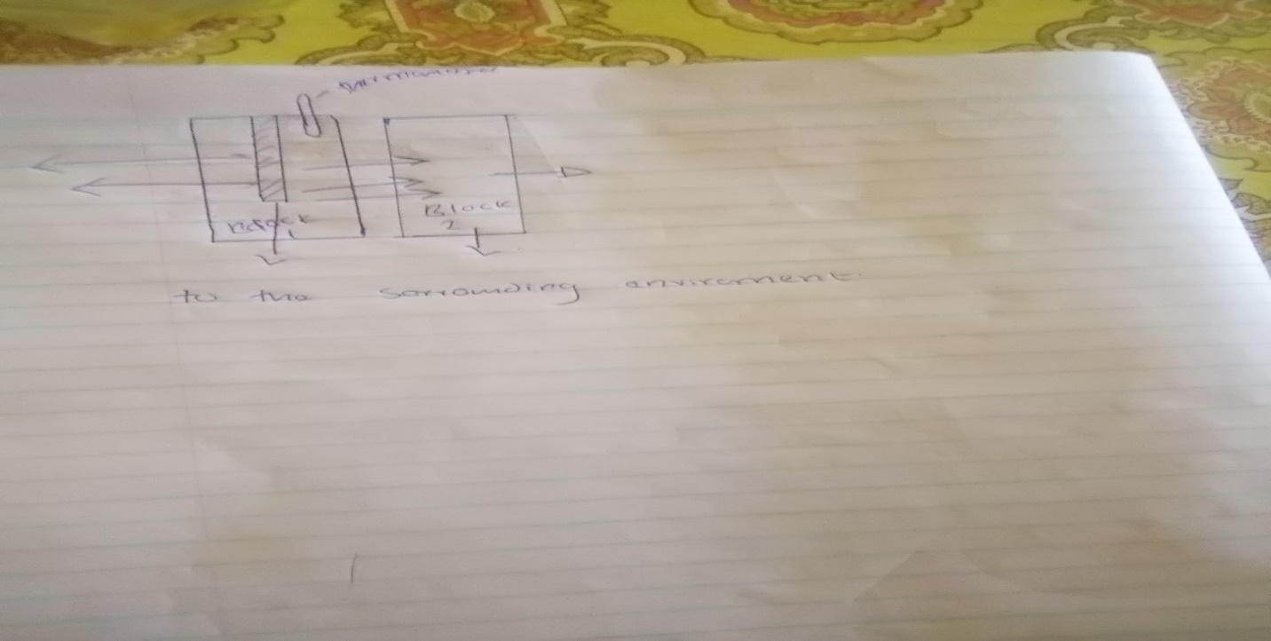

The heat in the surrounding environment is insignificant since the temperature that is coming from the environment is small at some time as compared to the heat that is coming from the heater ie heat can never flow from a region of low temperature to the region of high temperature.

1
- Heat supplied the heater= heat gained by the metal block
Ignoring any temp coming from the environment
Heat supplied by heater=VIt
Of which is unknown
Heat gained by metal block=mq or mc*change in temp

There4 heat supplied by heater=$\frac{86.4}{1000}*\frac{\frac{900j}{kg}}{k}*\left(18.66k\right)k=$1451.00joules
But we know I watt is equivalent to 1j/s
Converting our answer to wats
It will be 1451.00wats
So the electrical power is 1451.00watts

- At 5 minutes the energy is flowing into the system while at 15minutes its flowing out of the system.
At 5 minutes the heat is flowing from the system to the surrounding while at 15 minute heat is flowing from the environment to the system

At block A at 5minutes flow of energy= initial temperature=30.06 f
Final temperature=18.00
Flow of energy =$\frac{86.4}{1000}kg*\frac{\frac{900j}{kg}}{k}*12.06k=937j$
Flow of energy at block B at 5minutes=$\frac{86.4}{1000kg}*\frac{\frac{900j}{kg}}{k}*4.92k=382.58joules$
Flow of energy at 15minutes block a=$\frac{86.4}{1000kg}*\frac{\frac{900j}{kg}}{k}*_{-4.28}=-332.81joules$
Flow of energy at 15 minutes of block b=$\frac{86.4}{1000}kg*\frac{\frac{900j}{kg}}{k}*-0.85=-66.1j$

Therefore it can be seen that since the energy is flowing into the system its positive and since its flowing out of the system its negative. From the system to the surrounding environment

2.
a) at 1 to 2 the water is contracting as a result of temperature fall . this in turn is reducing the volume of of water as well as the density is increasing. The intermolecular forces that is being experienced is created by the water molecules which result in colliding with each other. So as the temp decrease the intermolecular forces reduce and the density of water increase.

Observing the graph keenly one will notice that the temperature will tend to increase ie somewhere in between 1 and 2. This will be caused by the temperature that is being produced by the vibration of the water particles. Due to the friction and lost of energy that result from collision will result to the increased in temp.

- The first law of thermal dynamic is the application of the conservation of energy principle to heat and thermodynamic process. In the graph the temperature is falling while the volume is increasing. The heat being supplied is reducing meaning there will have a change in internal energy as well as the work done and mass will increase since density is increasing. The internal energy that is the energy that is in water will reduce and while pressure will reduce. Since the pressure is reducing it means that the volume
- Determining temp and specific volume
T=B/A-log p
Case 1 with pressure being 10bar
T=1730.63/8-log7500)-233.426=186.12K
Case 2with pressure being 1 bar
T=1810.94/8-log750)-244.485=108.89K
Our assumption in each case was that a was 8 of which is8.07131 and 8.14019 respectively
.
Specific volume of the water= 1/density
Assuming that density is 1000kg/m^3 0f water
1/1000=1.0*10^-3kg/m^3
Assumption that we made is that density of water 1000kg/m^3 since the density will vary along the graph it will not be constant.

